Ethan Allen Dual Shift Cupboard

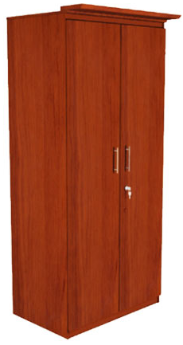

|  |
| --- |
| **DESCRIPTION** |
| Ethan Allen interior designing has introduced an extra slim dual wooden cupboard and a mirror attached with each door. The cupboard has a nice feel with smooth surface with a hang through look. It gives you and your house a complete different look with its slim design it will fit easily in narrow and hard to reach places plus its wooden structure is so strong and gravity applied to the centre helps it to maintain balance. |

|  |  |  |
| --- | --- | --- |
| **Price** | **650$** | |
| **Dimensions** | **H** x **W** x **L** | **75in x 22in x 27in** |
| **Features** | **The slim design enables us to move the cupboard and fit it to any place even in small bathrooms and store rooms.** | |
| **Finished** | **Wooden pattern gloss** | |
| **Available in** | **Brown and Bold Black** | |